

OOAD

Project Deliverable 2



**GROUP MEMBERS**

Muhammad Talha Riaz (BSEF19A020)

Hamza Jamil (BSEf19a013)

**SEQUENCE DIAGRAMS:**

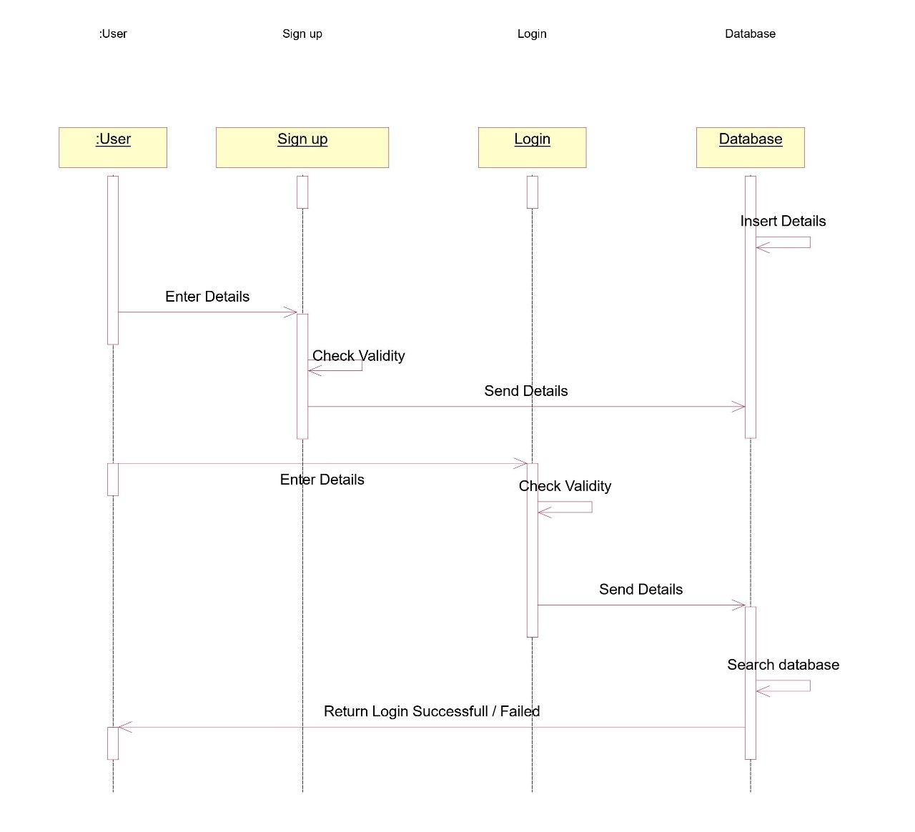

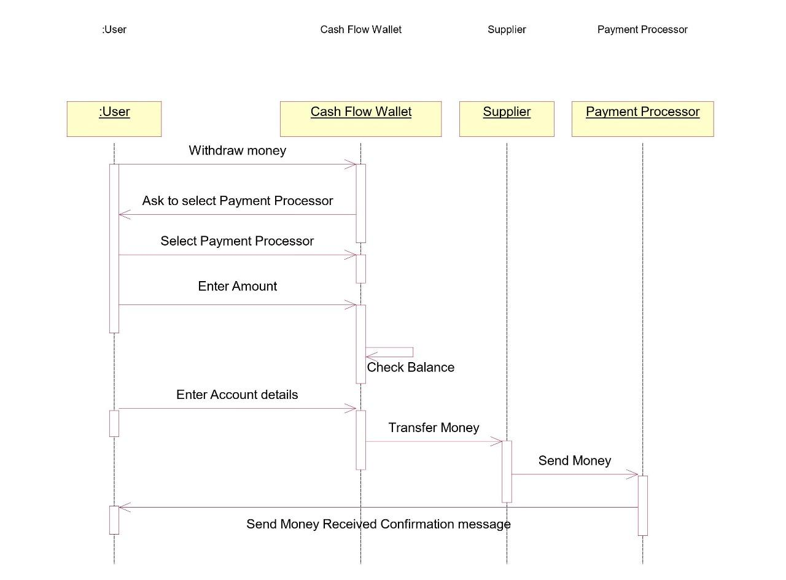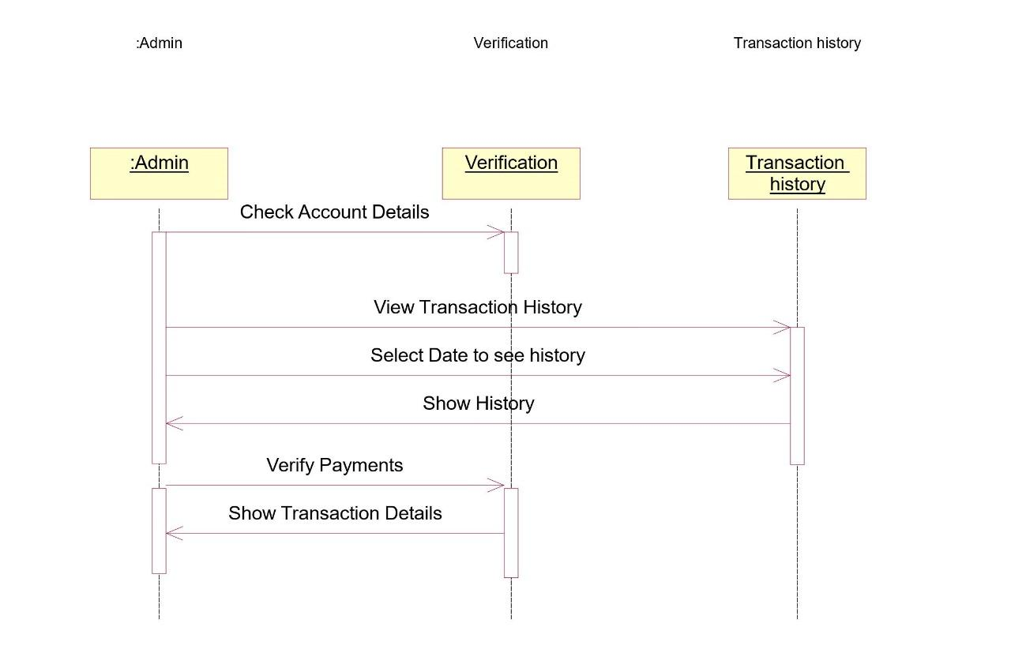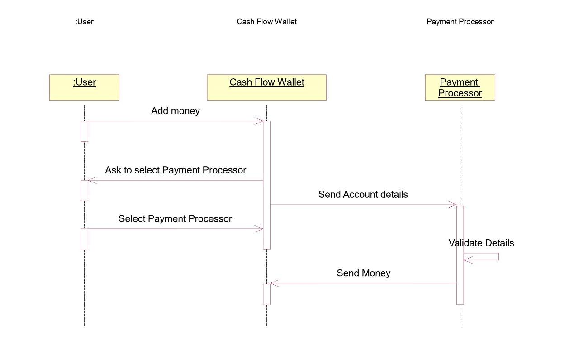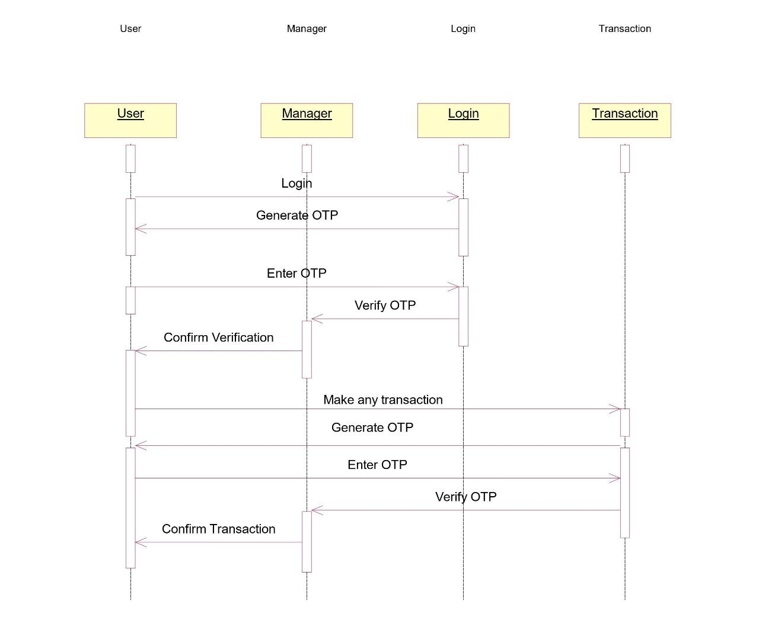

**COLLABORATION DIAGRAMS:**

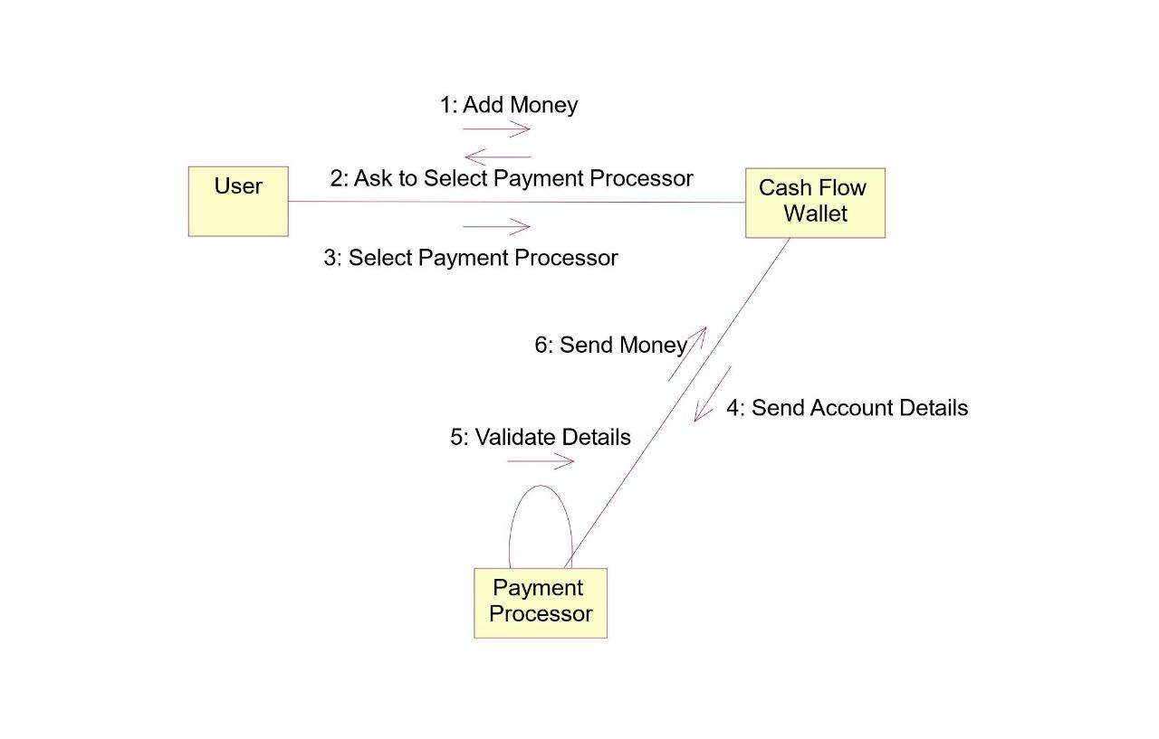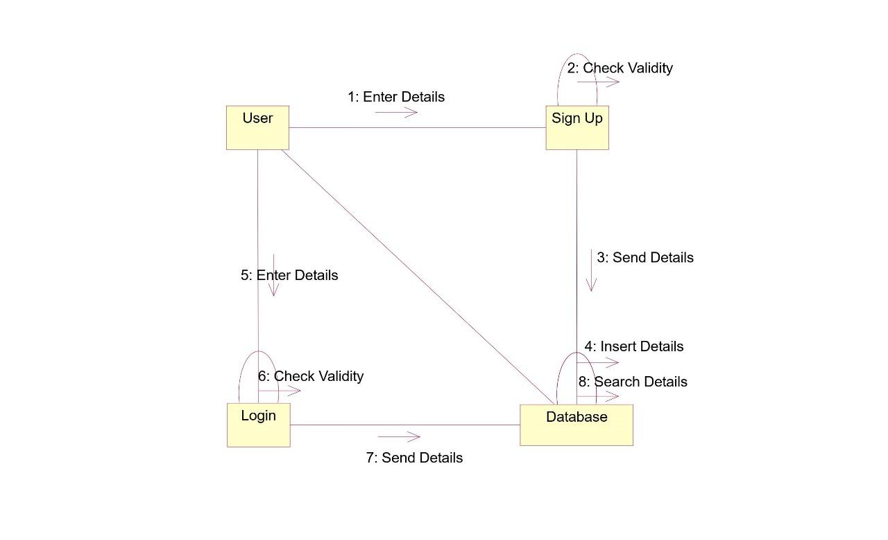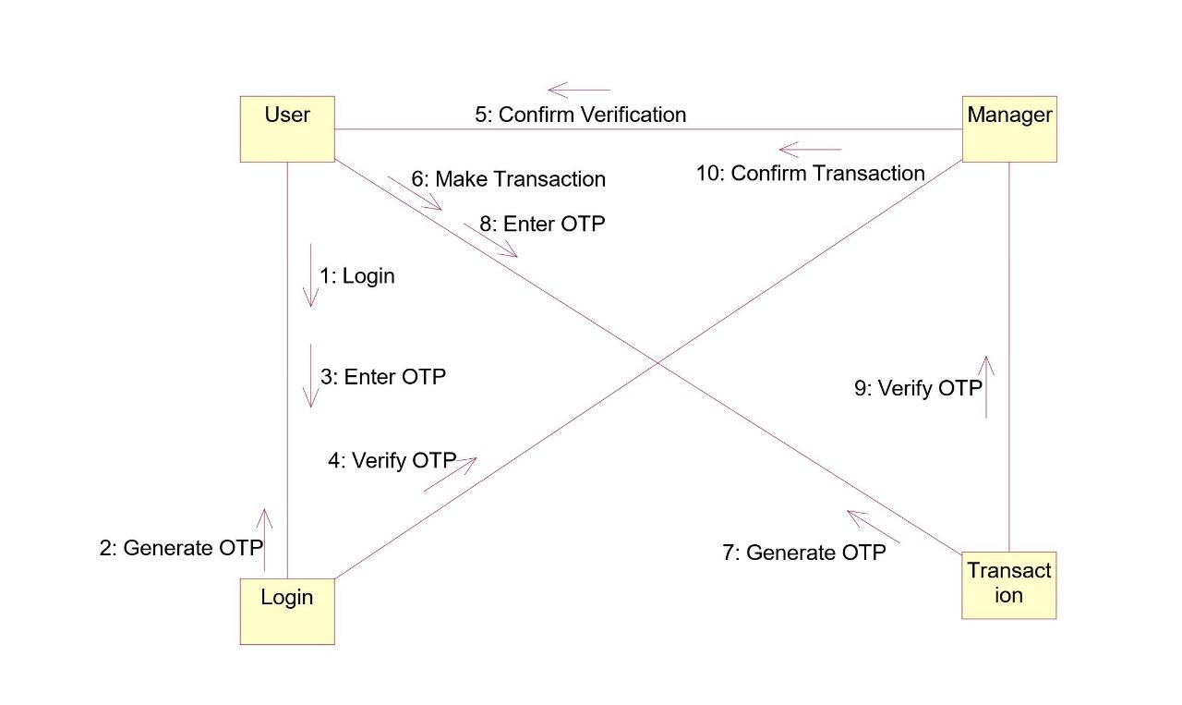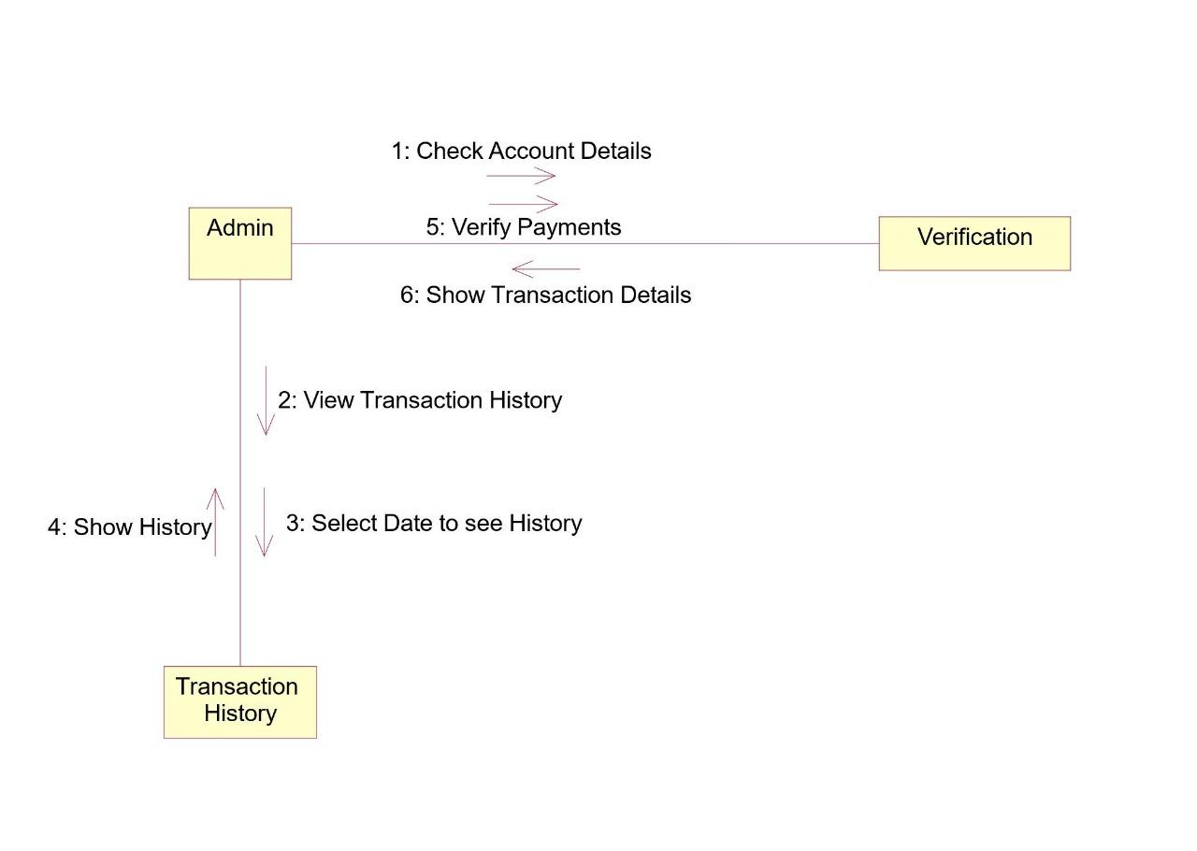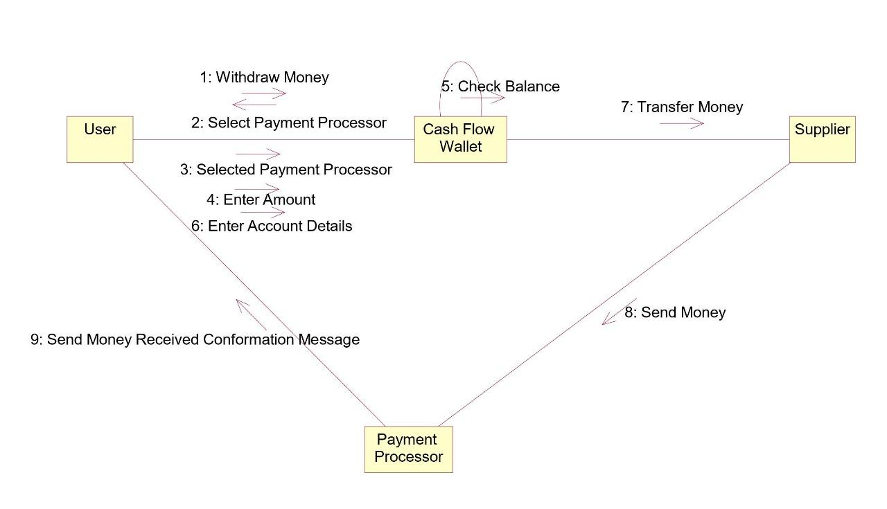

**SSD:**

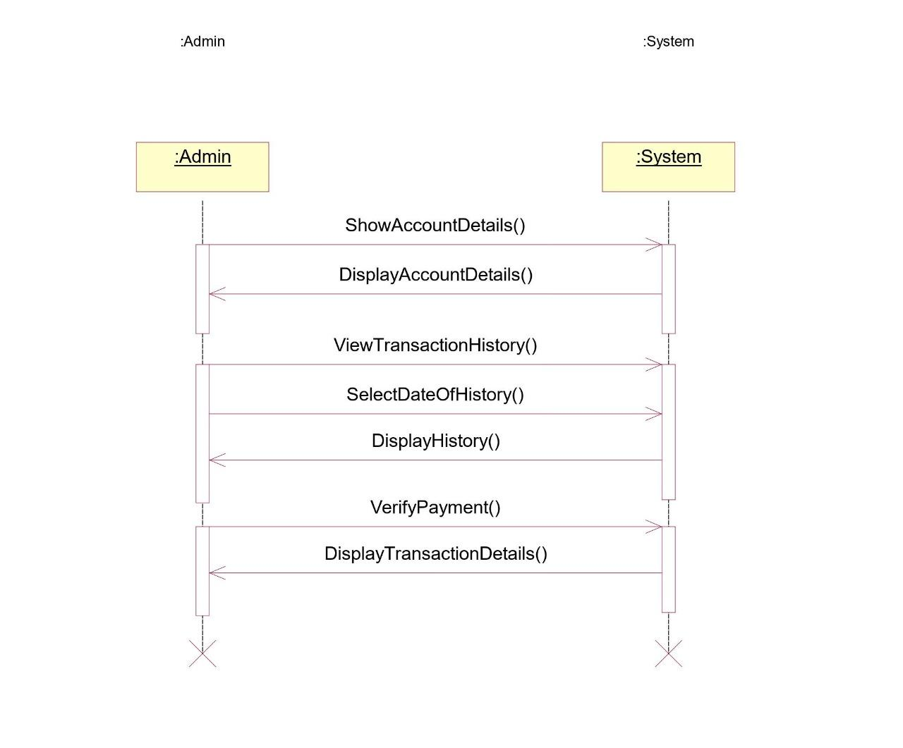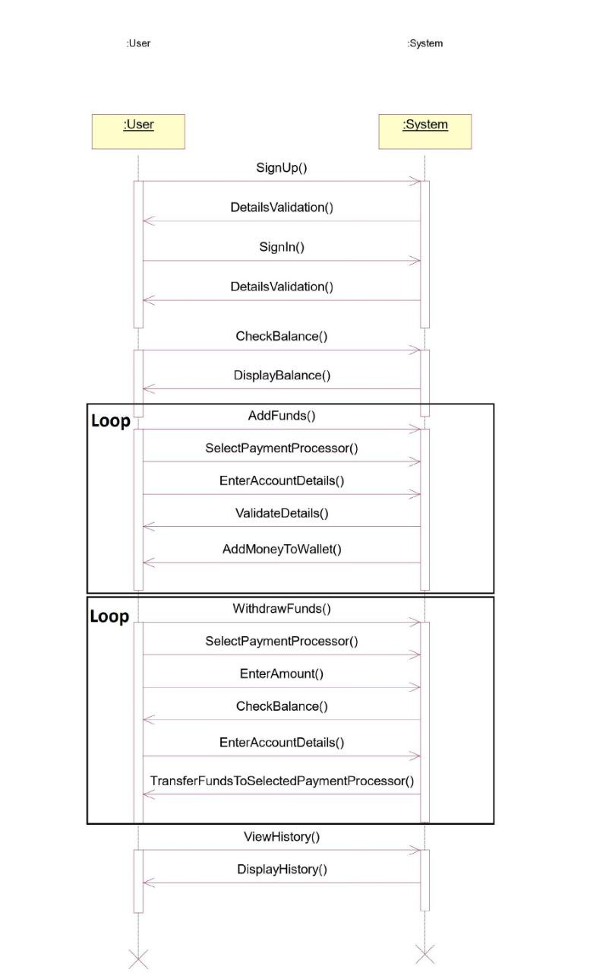

**PROTOTYPE:**

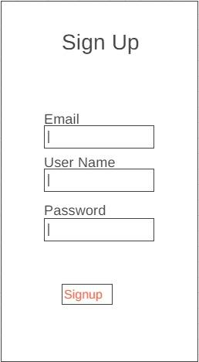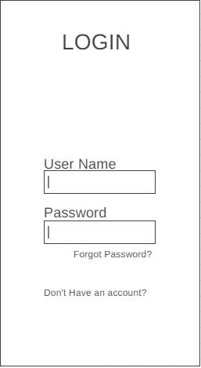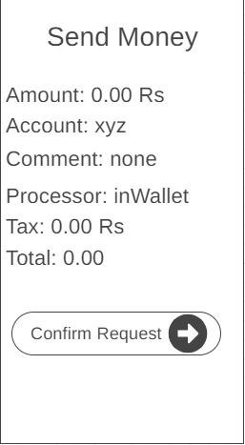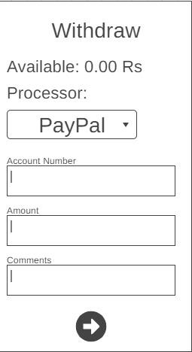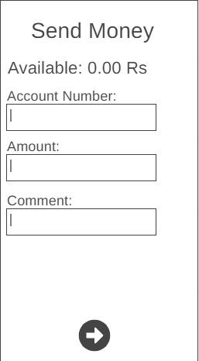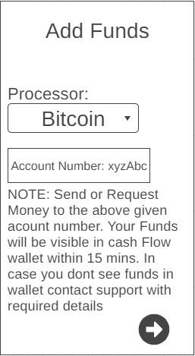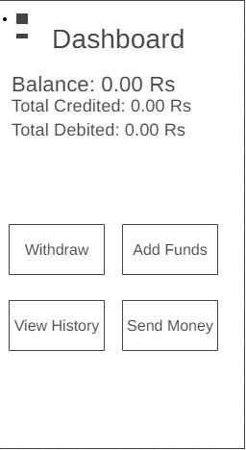

**ARCHITECTURE:**

**MVC**

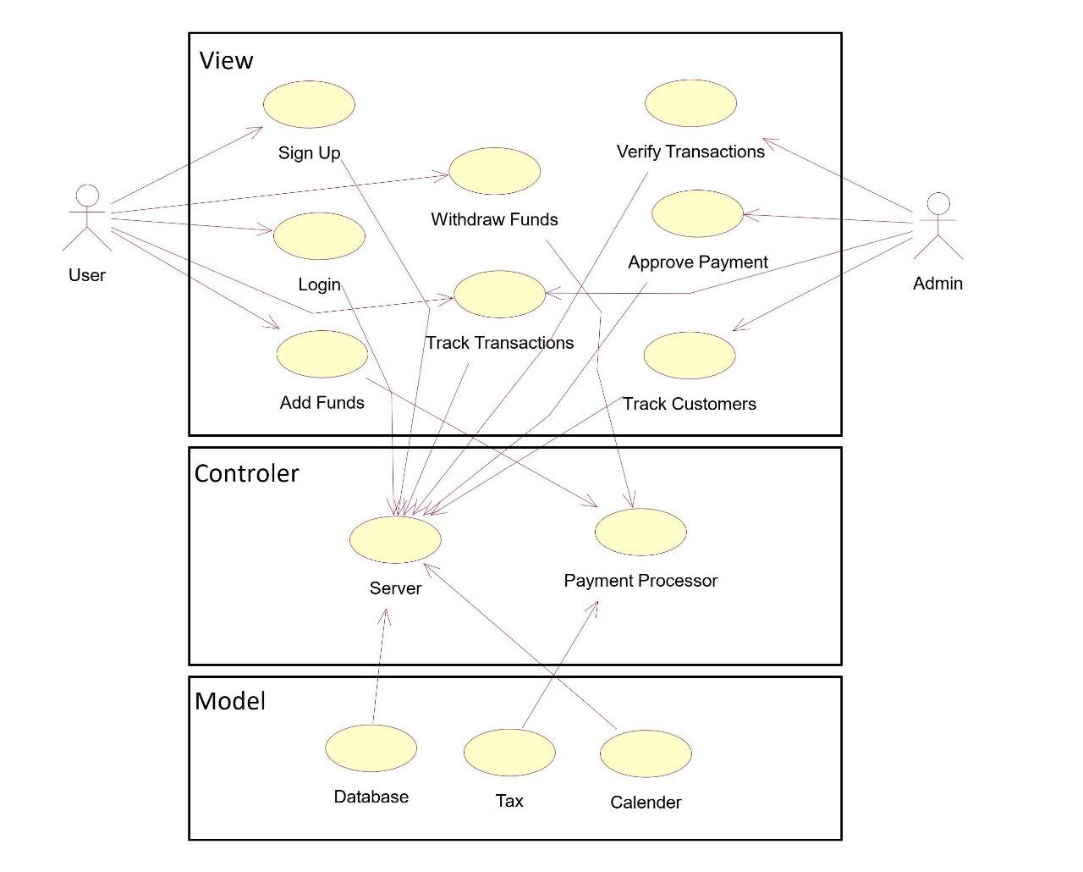

**DCD:**

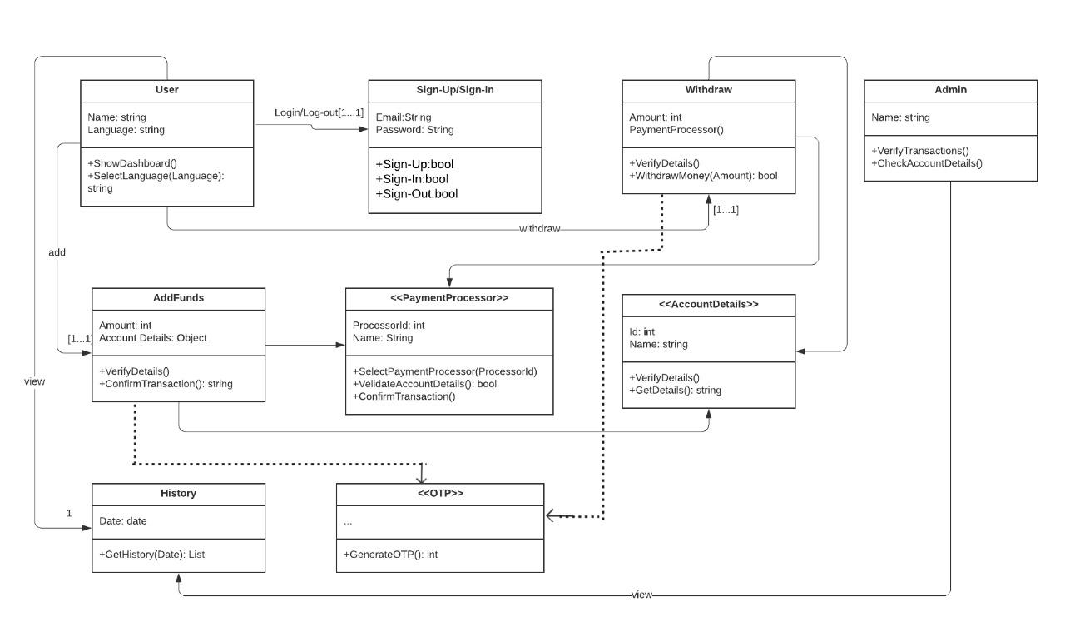

**USECASE CONTRACTS:**

**Primary Actors:**

1. User

2. Admin

**User:**

**1. Add Funds:**

​Actor: User

​Pre condition: Payment processor should be available and account details should be valid.

Scenario: User will add money to Cash Flow from any payment processor available on cash flow.

Post Condition: Payment is successful and funds are added.

**2. Withdraw Funds:**

​Actor: User

​Pre Condition: Funds are Available in Cash Flow Wallet

Scenario: User will take out his money from cash Flow system\Wallet to any Payment Processor\ Bank available on cash flow.

Post Condition: Funds are Successfully transferred from cash flow wallet to user selected payment processor wallet.

**Admin:**

**1. Verify Transactions:**

Actor: Admin

Pre Condition: Account Details are Valid

Scenario: Admin verifies the transaction by checking if the account is valid or not and the transaction is verified or not.

Post Condition: Transaction is verified and funds are added or subtracted from wallet.

**2. Track transactions:**

Actor: Admin

Pre condition: Previous transactions are available in database.

Scenario: Admin tracks the transaction of specified time period.

Post Condition: transaction history is shown to admin.